
Value Stream Map Swimlane Diagram Template Example
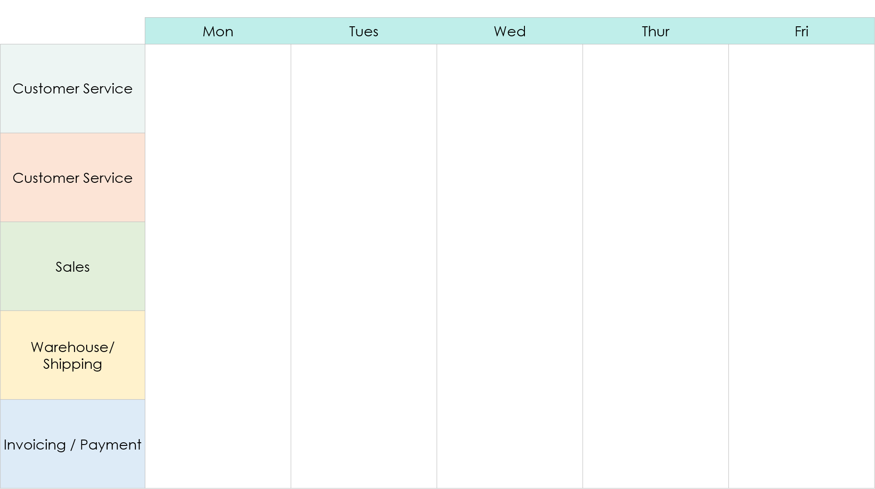
Example
NO
YES
Order Received
Check Payment Method
In Stock?
Check Stock
Cancel Order
Receive Order
YES
Notify Customer
Submit Order
Form Complete?
DIAMOND:
Decision
OVAL: Start / End
Notification
Order Placed
Issue Invoice
YES
NO
NO
Valid Payment?
Ship Order
Receive Goods
NO
YES
Decision
(Yes or No Question)
?
Decision
(Yes or No Question)

End Step
Process Step
Milestone
Process Step

Process Step

YES
In Stock?
NO
Process Step

YES
Start
DIAMOND:
Decision
OVAL: Start / End
Milestone

Milestone

Process Step

Process Step

NO
Process Step
DISCLAIMER

Any articles, templates, or information provided by Smartsheet on the website are for reference only. While we strive to keep the information up to date and correct, we make no representations or warranties of any kind, express or implied, about the completeness, accuracy, reliability, suitability, or availability with respect to the website or the information, articles, templates, or related graphics contained on the website. Any reliance you place on such information is therefore strictly at your own risk.

