
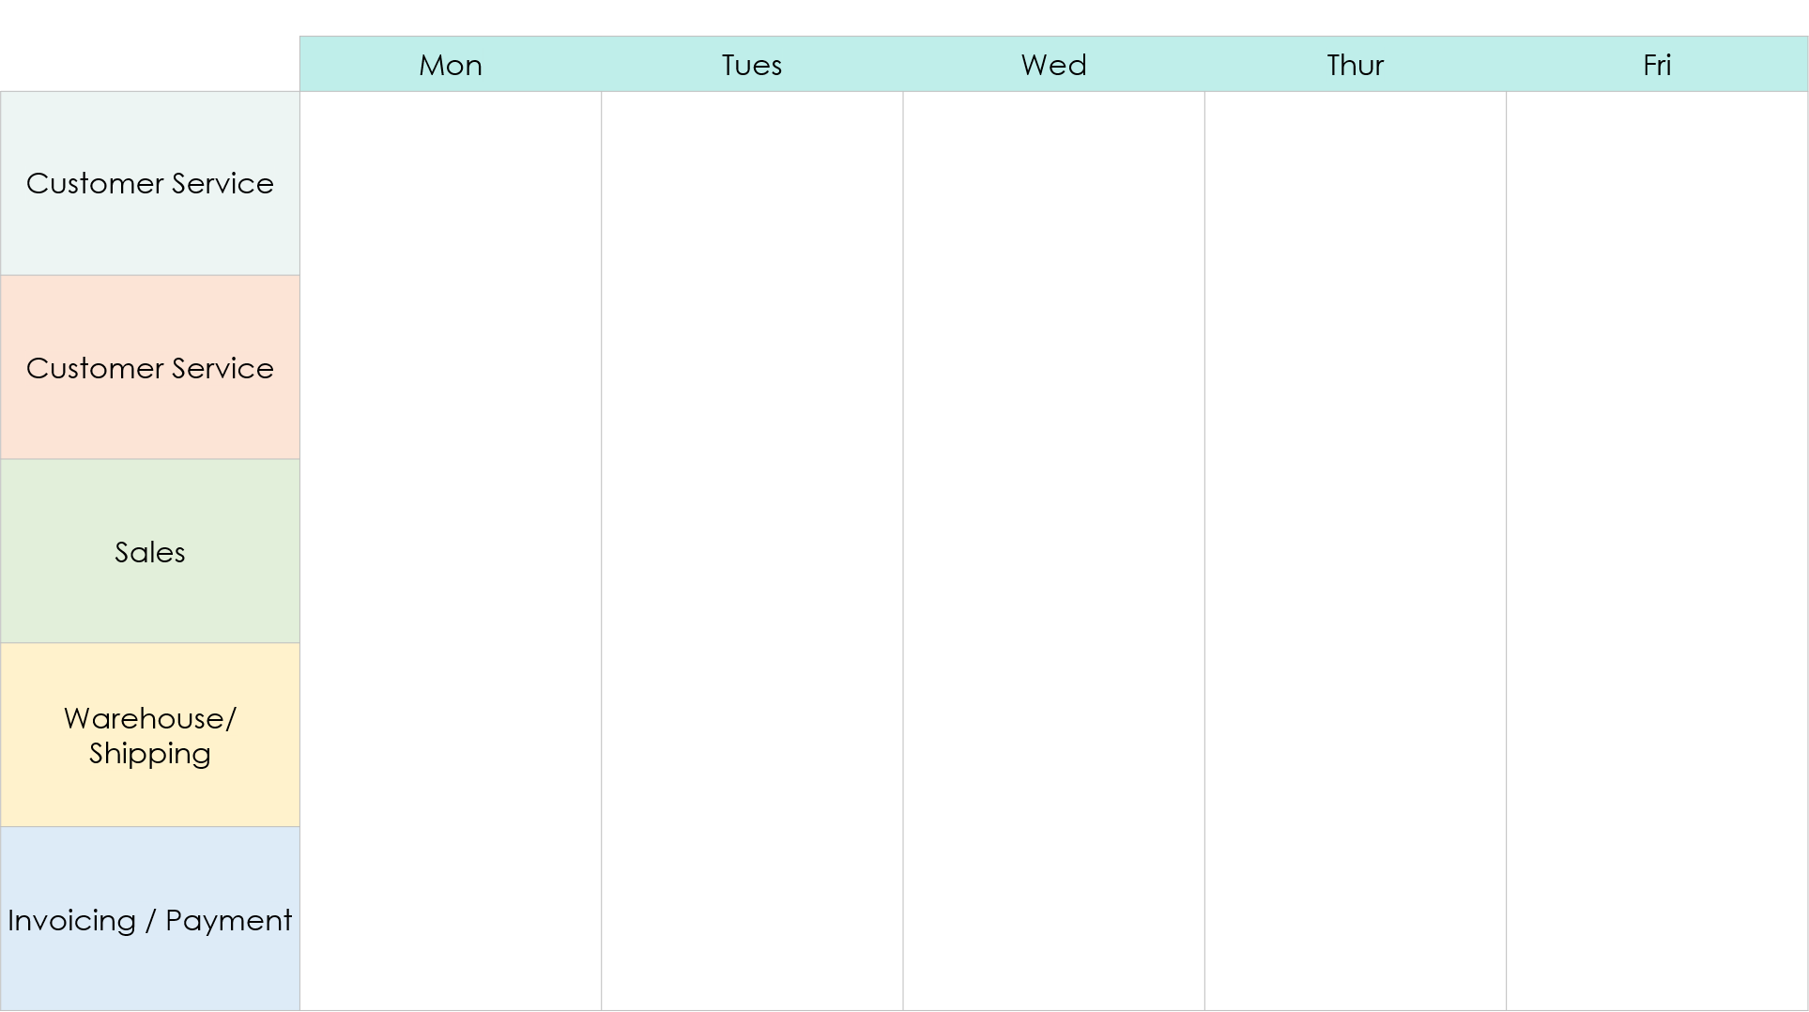
Value Stream Map Swimlane Diagram Template
NO
YES
Decision
(Yes or No Question)
?
Decision
(Yes or No Question)

End Step
Process Step
Milestone
Process Step
Process Step

YES
In Stock?
NO
Process Step

Process Step
Process Step
YES
NO
Start
DIAMOND:
Decision
OVAL: Start / End
Milestone

Milestone

Process Step

DISCLAIMER

Any articles, templates, or information provided by Smartsheet on the website are for reference only. While we strive to keep the information up to date and correct, we make no representations or warranties of any kind, express or implied, about the completeness, accuracy, reliability, suitability, or availability with respect to the website or the information, articles, templates, or related graphics contained on the website. Any reliance you place on such information is therefore strictly at your own risk.

