
Epic-Focused User Story Template
EPICS | DESCRIPTION | USER ROLES | USER GOALS | USER STORIES | TASKS | ACCEPTANCE CRITERIA | DEPENDENCIES | PRIORITY | RELEASE PHASE
 | Dependency  Acceptance Criteria  User Stories  Release Phase  Medium Priority  Dependency  Acceptance Criteria  User Stories  User Role  Epic Description  Epic Description  EPIC NAME 1 | User Role | User Goals | User Stories  User Stories | User Task  User Task | High Priority  Acceptance Criteria  Acceptance Criteria | Dependency  Dependency |  | Release Phase
EPIC NAME 2 |  | User Role  User Role | User Goals |  | User Task  User Task
Dependency
Acceptance Criteria
User Task
User Stories
Release Phase
High Priority
Dependency
Acceptance Criteria
User Task
User Stories
User Goals
User Role
User Role
Epic Description
EPIC NAME 3
Dependency
Acceptance Criteria
User Task
User Stories
Release Phase
Low Priority
Dependency
Acceptance Criteria
User Task
User Stories
User Goals
User Role
User Role
Epic Description
EPIC NAME 4
EPIC NAME 5
Epic Description
User Role
User Role
User Goals
User Stories
User Task
Acceptance Criteria
Dependency
High Priority
Release Phase
User Stories
User Task
Acceptance Criteria
Dependency

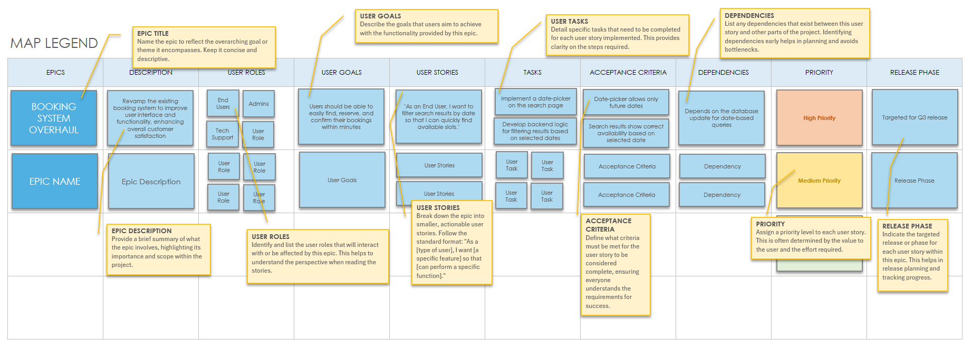

DISCLAIMER

Any articles, templates, or information provided by Smartsheet on the website are for reference only. While we strive to keep the information up to date and correct, we make no representations or warranties of any kind, express or implied, about the completeness, accuracy, reliability, suitability, or availability with respect to the website or the information, articles, templates, or related graphics contained on the website. Any reliance you place on such information is therefore strictly at your own risk.

