**](https://www.smartsheet.com/try-it?trp=12149&utm_source=template-word&utm_medium=content&utm_campaign=Blank+Basic+Value+Stream+Map-word-12149&lpa=Blank+Basic+Value+Stream+Map+word+12149)Basic Value Stream Map   
Template**

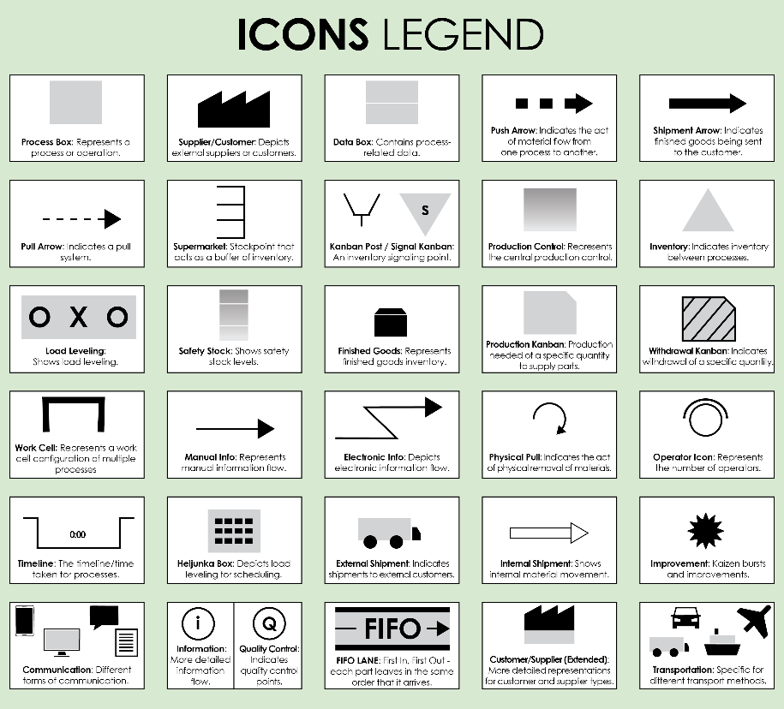

For descriptions, see **VSM Icons Legend** on Page 4 of this document.

To create your own VSM, copy and paste icons from the **VSM Icons** on Page 5 of this document.

To create your own VSM, copy and paste icons from the **VSM Icons** on Page 5 of this document.

Recommendations:

Bottlenecks:

NOTES

TITLE: Title here

Process Steps

**TOTAL LEAD TIME: 0 hours 00 minutes**

**TOTAL CYCLE TIME: 0 hours 00 minutes**

TITLE: Customer Support Process VSM

**EXAMPLE** Process Steps

Recommendations:  Implement automated issue categorization and assignment to reduce lead times.

Bottlenecks: Issue assignment and resolution stages often face delays.

NOTES

**TOTAL LEAD TIME: 1 hour 27 minutes**

**TOTAL CYCLE TIME: 59 minutes**

**wait**

**wait**

**wait**

**wait**

**wait**

**process time**

**process time**

**process time**

**process time**

**process time**

**process time**

Customer Contact

***Activity: Customer initiates contact via phone, email, or chat.***

***LT: 5 minutes***

***PT: 2 minutes***

***Resources: Customer support agent***

Issue Logging

***Activity: Agent logs the issue in the support system.***

***LT: 3 minutes***

***PT: 2 minutes***

***Resources: Support software***

Issue Categorization

***Activity: Agent categorizes the issue based on type and severity.***

***LT: 4 minutes***

***PT: 3 minutes***

***Resources: Support agent***

Issue Assignment

***Activity: Issue is assigned to the appropriate department or specialist.***

***LT: 5 minutes***

***PT: 2 minutes***

***Resources: Support agent, routing system***

Resolution

***Activity: Specialist resolves the issue.***

***LT: 1 hour***

***PT: 45 minutes***

***Resources: Specialist, support tools***

Customer Feedback

***Activity: Agent follows up for customer feedback.***

***LT: 10 minutes***

***PT: 5 minutes***

***Resources: Customer support agent***

Supplier

Customer

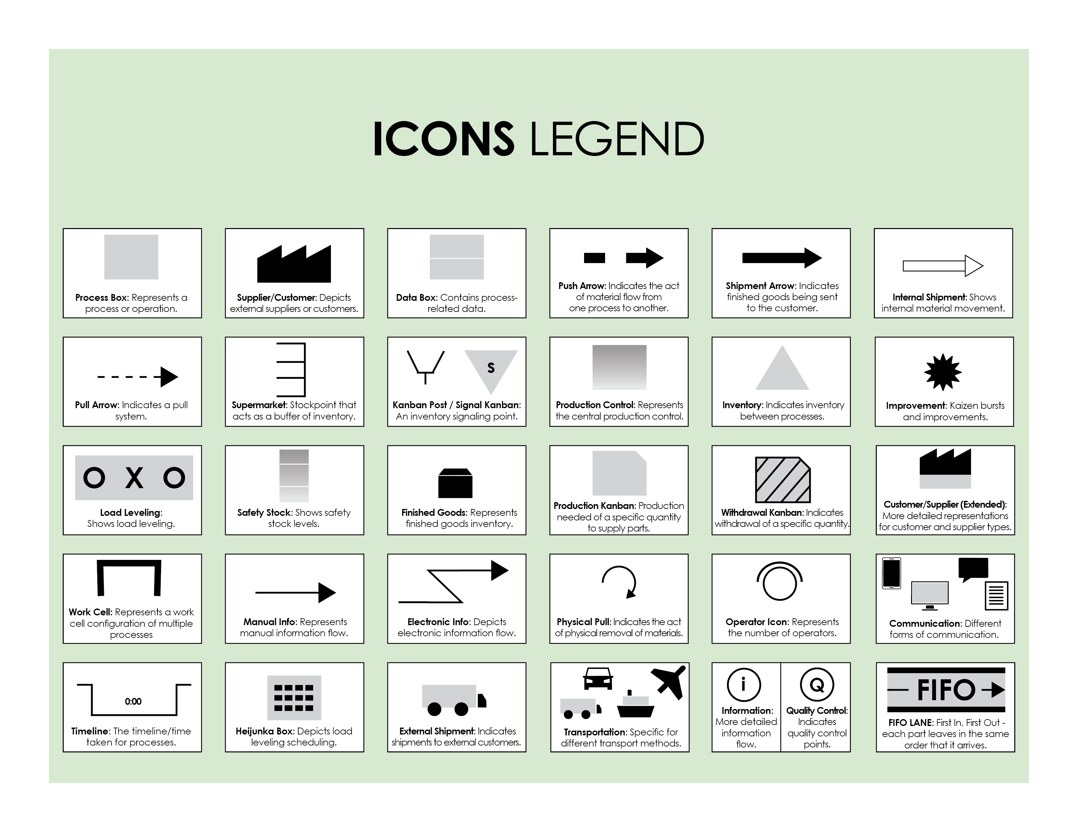

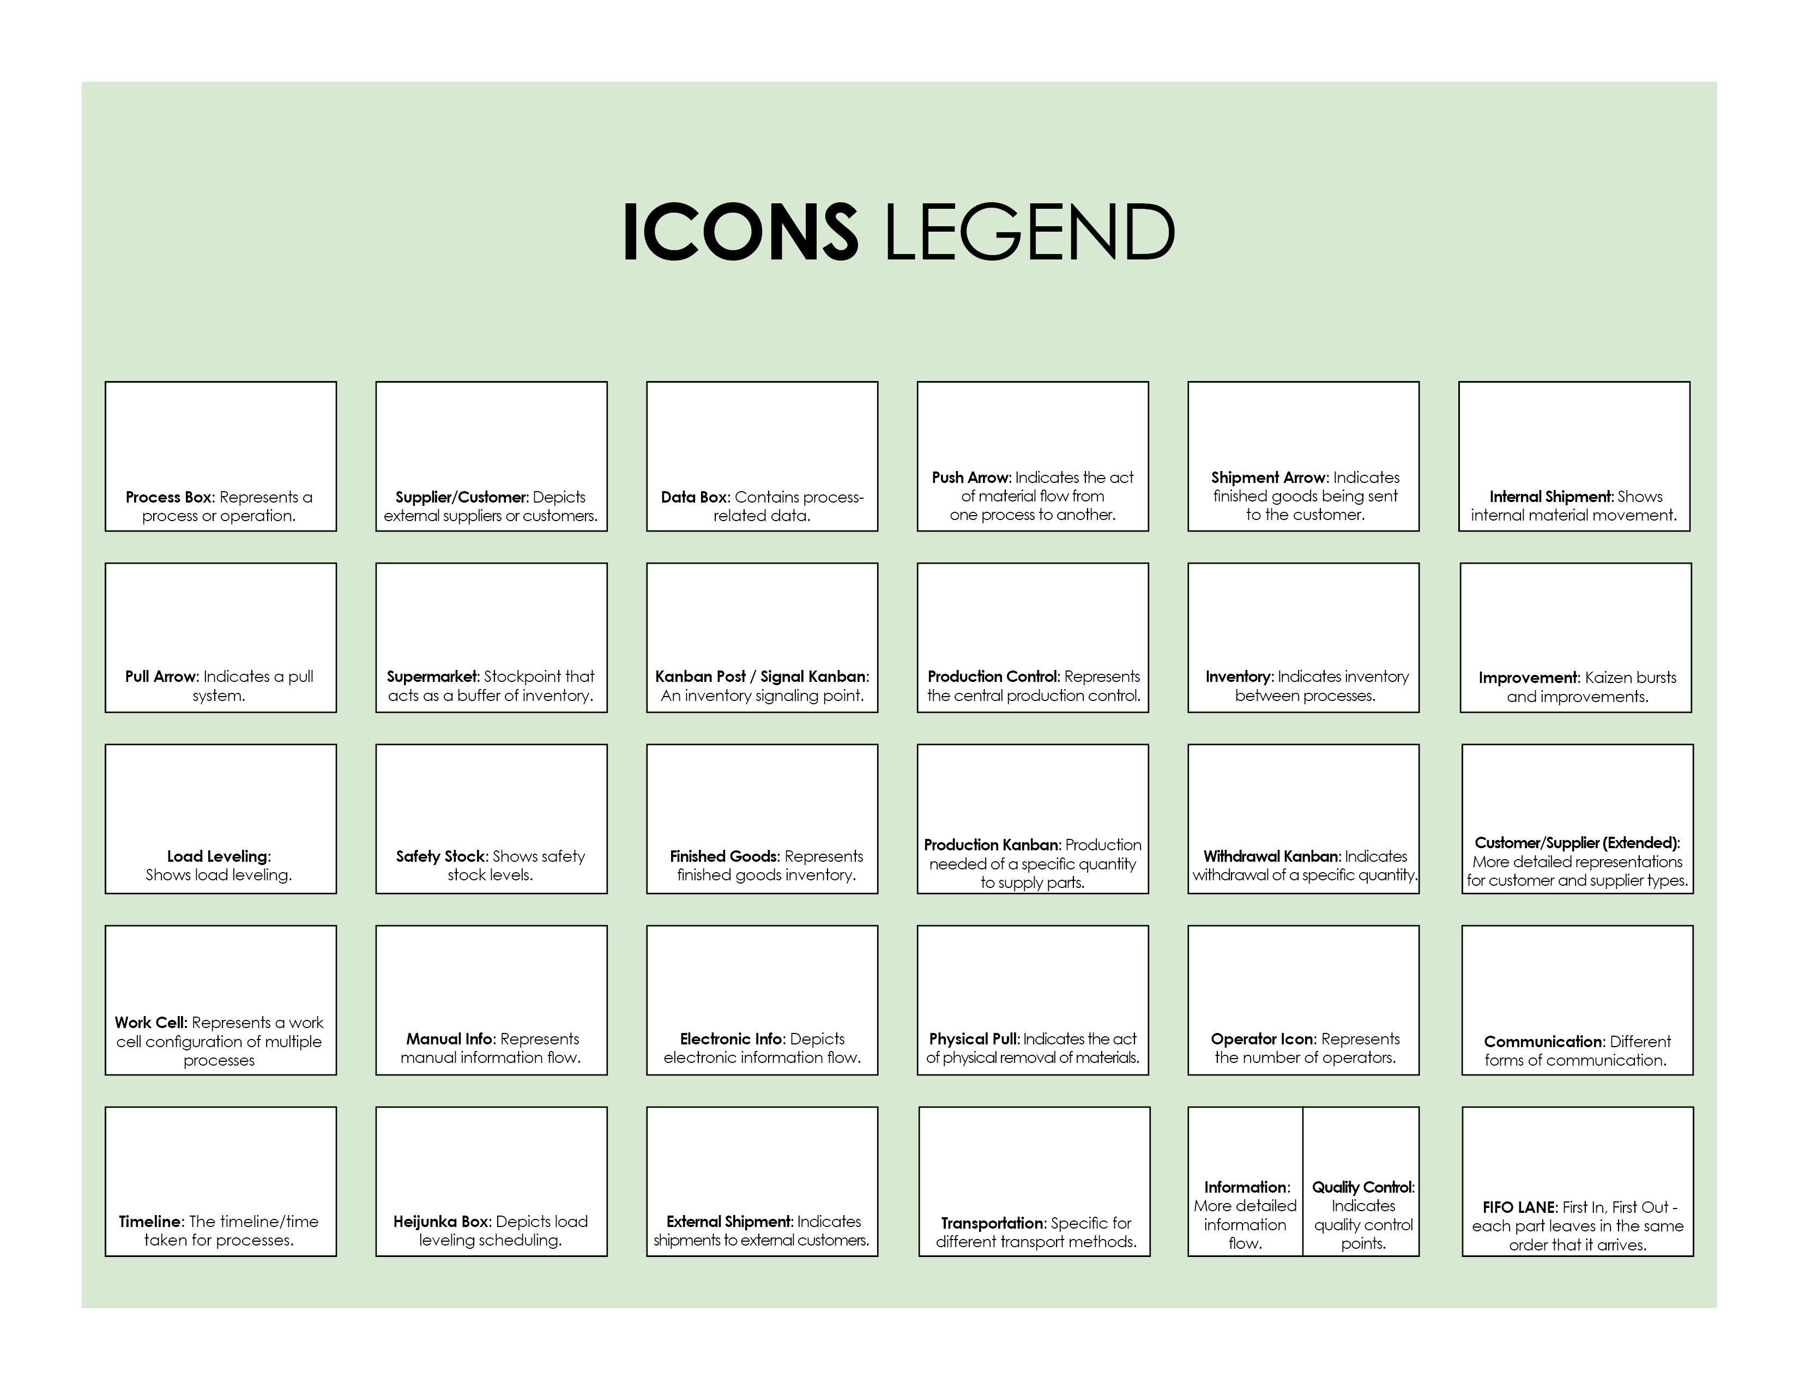

Copy and paste the icons below to create your own VSM.



|  |
| --- |
| **DISCLAIMER**  Any articles, templates, or information provided by Smartsheet on the website are for reference only. While we strive to keep the information up to date and correct, we make no representations or warranties of any kind, express or implied, about the completeness, accuracy, reliability, suitability, or availability with respect to the website or the information, articles, templates, or related graphics contained on the website. Any reliance you place on such information is therefore strictly at your own risk. |