**](https://www.smartsheet.com/try-it?trp=12095&utm_source=template-word&utm_medium=content&utm_campaign=Example+Wedding+Event+Proposal-word-12095&lpa=Example+Wedding+Event+Proposal+word+12095)**

**Wedding Event   
Proposal Template Example**

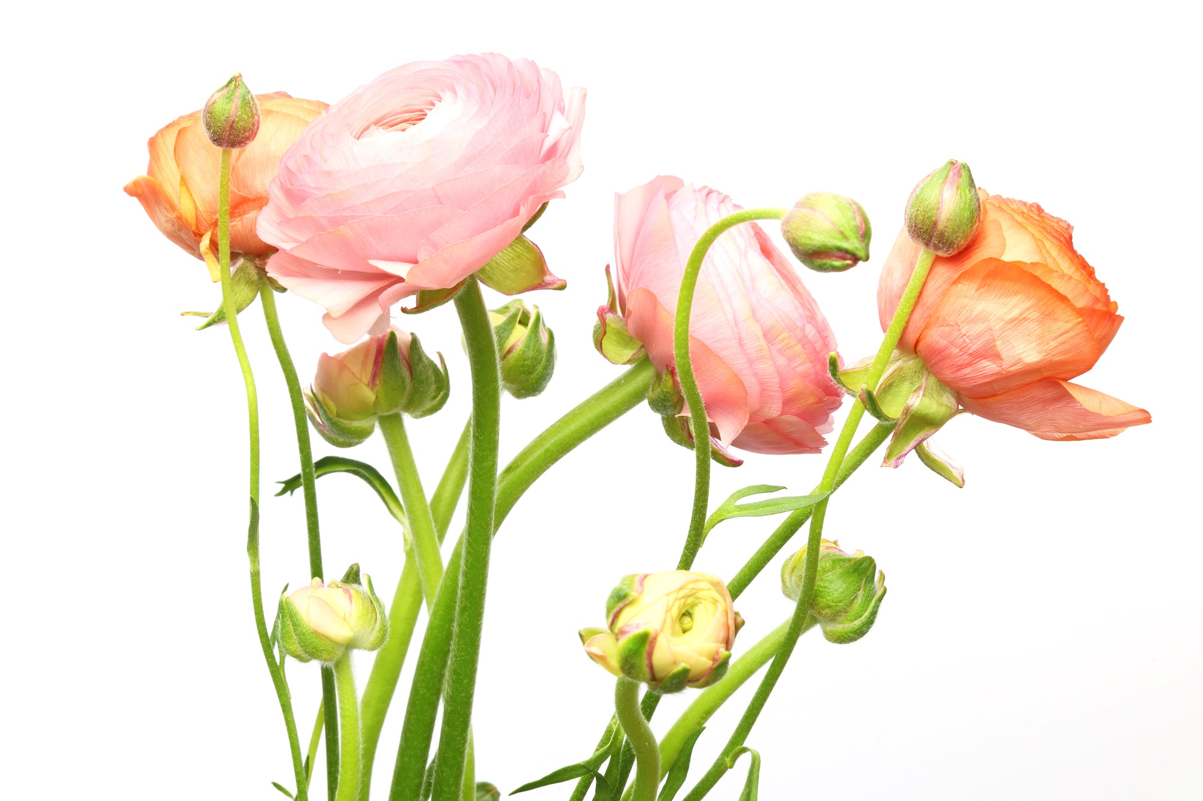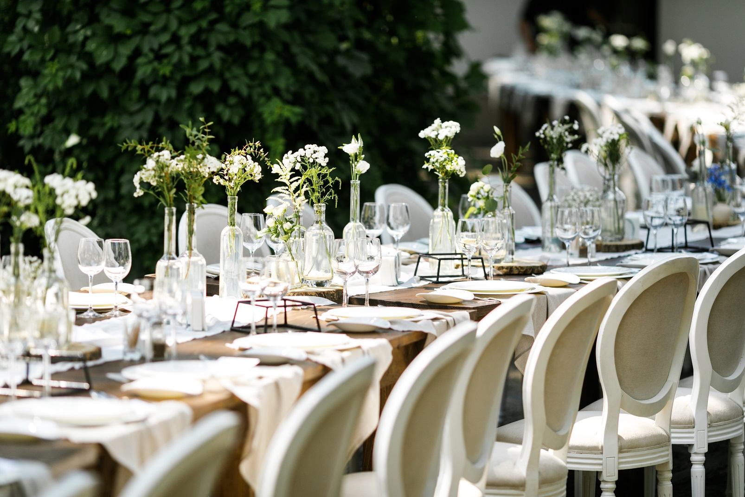DREAMS COME TRUE:  
A Wedding Proposal

|  |  |
| --- | --- |
| EVENT NAME | The Union of Sarah and Alex |
| DATE OF PROPOSAL SUBMISSION | August 1, 20XX |
| PREPARED FOR | The Thompson Family |
| PREPARED BY | Romy Bailey, Rose Petal Weddings |

# INTRODUCTION

|  |
| --- |
| Welcome to the first step in bringing your dream wedding to life. This proposal is tailored for couples like Sarah and Alex, who are embarking on the journey of organizing their special day. It is designed to simplify the planning process, ensuring every detail resonates with your vision. |

# vision and theme

|  |  |
| --- | --- |
| THEME AND COLOR SCHEME | Enchanted Forest: Emerald green and gold |
| LINK TO INPSIRATIONAL MOOD BOARD OR IMAGES | Candles and lights in forest |

# VENUE SELECTION

|  |  |  |  |  |
| --- | --- | --- | --- | --- |
| POTENTIAL VENUES | CAPACITY | AVAILABLE DATES | PROS | CONS |
| Whispering Pines | 150 guests | October 5 or 12 | Scenic outdoor area, on-site accommodations |  |
|  |  |  |  |  |
|  |  |  |  |  |
|  |  |  |  |  |
|  |  |  |  |  |

# CATERING AND MENU OPTIONS

|  |
| --- |
| • Starter: Wild Mushroom Soup  • Main Course: Choice of Seared Salmon or Roasted Portobello Mushrooms  • Dessert: Lemon Tart with Fresh Berries  • Dietary Accommodations: Gluten-free and vegan options available |

# décor AND STYLING

|  |
| --- |
| Themes of the enchanted forest will be brought to life with cascading fairy lights, moss-covered centerpieces, and gold-accented table settings. |

# ENTERTAINMENT AND AUDIO-VISUAL NEEDS

|  |
| --- |
| • DJ for reception dance floor.  • String Quartet for the ceremony.  • Photo Booth with themed props. |

# PHOTOGRAPHY AND VIDEOGRAPHY

|  |
| --- |
| Style: Candid and Magical Moments  Special Moments: First look in the forest, sunset vows |

# ATTIRE AND BEAUTY

|  |
| --- |
| Bride's Attire: A-line gown with lace detailing  Groom's Attire: Classic black tuxedo  Beauty Services: On-site hair and makeup for the bridal party |

# GUEST EXPERIENCE

|  |
| --- |
| • Accommodations: Reserved block of rooms at Whispering Pines  • Transportation: Shuttle service from hotel to venue  • Activities: Guided nature walk on the morning of the wedding |

# TIMELINE AND SCHEDULE

|  |  |
| --- | --- |
| CEREMONY | 3:00 P.M. |
| COCKTAIL HOUR | 4:00 P.M. |
| RECEPTION | 5:00 P.M. |

# BUDGET OVERVIEW

ANTICIPATED COSTS

|  |  |  |  |  |  |  |
| --- | --- | --- | --- | --- | --- | --- |
| VENUE RENTAL | FOOD AND BEVERAGE | DECOR | ENTERTAINMENT | ATTIRE AND BEAUTY | PHOTOGRAPHY AND VIDEOGRAPHY | **TOTAL** |
| $5,000 | $10,000 | $3,000 | $2,500 | $2,500 | $4,000 | **$27,000** |

# ADDITIONAL SERVICES

|  |
| --- |
| • Wedding Favors: Customized miniature enchanted forest terrariums  • Ceremony Officiant: Reverend Lori Garcia |

APPROVAL FOR NEXT STEPS

Please review the provided details and indicate any changes or additional requests. Once approved, we will proceed with securing the bookings and finalizing the arrangements.

|  |  |  |
| --- | --- | --- |
| SIGNATURE |  |  |
| Name | | |



|  |
| --- |
| DATE |
| MM/DD/YY | |

|  |
| --- |
| **DISCLAIMER**  Any articles, templates, or information provided by Smartsheet on the website are for reference only. While we strive to keep the information up to date and correct, we make no representations or warranties of any kind, express or implied, about the completeness, accuracy, reliability, suitability, or availability with respect to the website or the information, articles, templates, or related graphics contained on the website. Any reliance you place on such information is therefore strictly at your own risk. |